Go to https://sc4.edu/password-reset/. You will need your SC4 acceptance letter with your temporary password. If you do not have your acceptance letter, please call 810-989-5500 to obtain the temporary password. Click ‘Register your account’. This will redirect you to a Microsoft site and ask for your email which is your Portal username + @student.sc4.edu, follow instructions. Next, click ‘Change your password’ at https://sc4.edu/password-reset/. Once you have registered your account and changed your password, go to https://portal.sc4.edu.
Set up email by clicking ‘College email’. The password is the same that you use for Portal.
Taking an online class? The Canvas online classroom uses your SC4 email and your Portal password.
Want to use online library resources? Your username and password are the same as Portal.

Your Portal homepage gives you campus announcements, links to important resources like email, Canvas and bookstore, class cancelations and bookmarks/campus links including links to the SC4 Library and to make an advising appointment. Explore!

Service Center

Click here, more stuff!!

Clicking on the ‘User Options’ tab will take you to links where you can update personal information, such as address and phone number. ‘Academics’ is where you can view grades, request a transcript, and more! Take time to explore the information available to you!

Ok, ok, but how do I register??
Click on “Student Planning” then “Go to Plan & Schedule”

Use the “Search for courses” box to search for classes.
To add the selected section to your plan for the current semester click on “Add Section to Schedule”. (To plan the course for a future semester click on “Add Course to Plan” and select the semester you plan to take the course.)
Adding the section to your schedule does not register you for the course. You must go back to the “Student Planning” link located on the top left hand of the page, and then click “Plan & Schedule”.
Click the “Register” under the course to register for the selected section.
Pay attention to any messages you receive when registering. A properly register course should say “Registered”.

You can review degree requirements and progress by clicking on the “Go to My Progress” under “Service Center”, “Student Planning”.
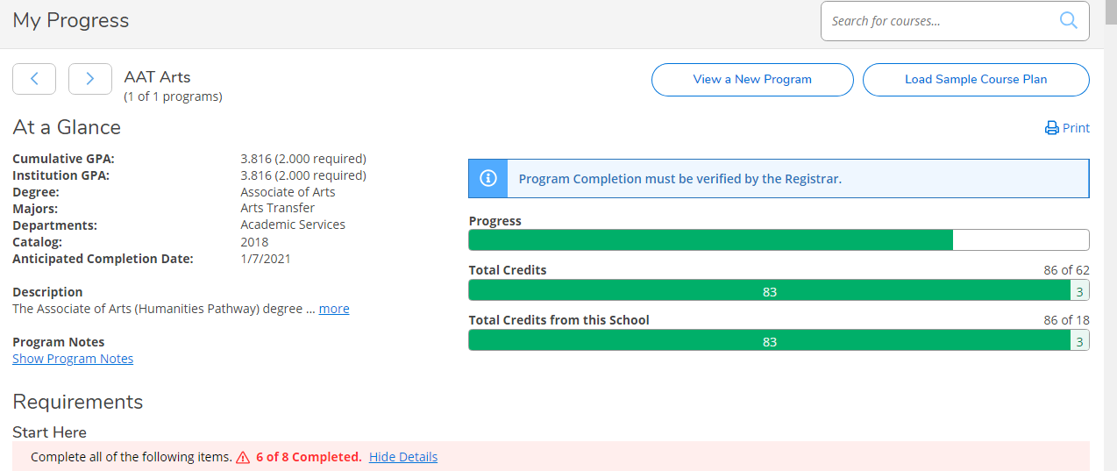
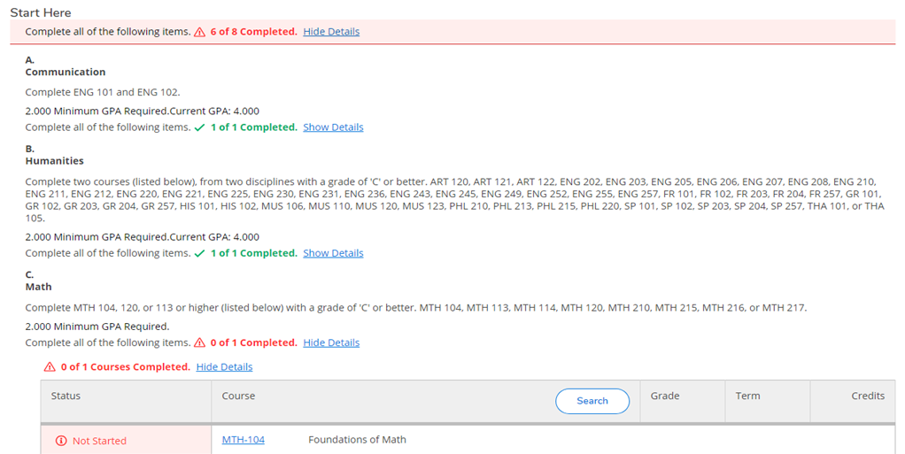
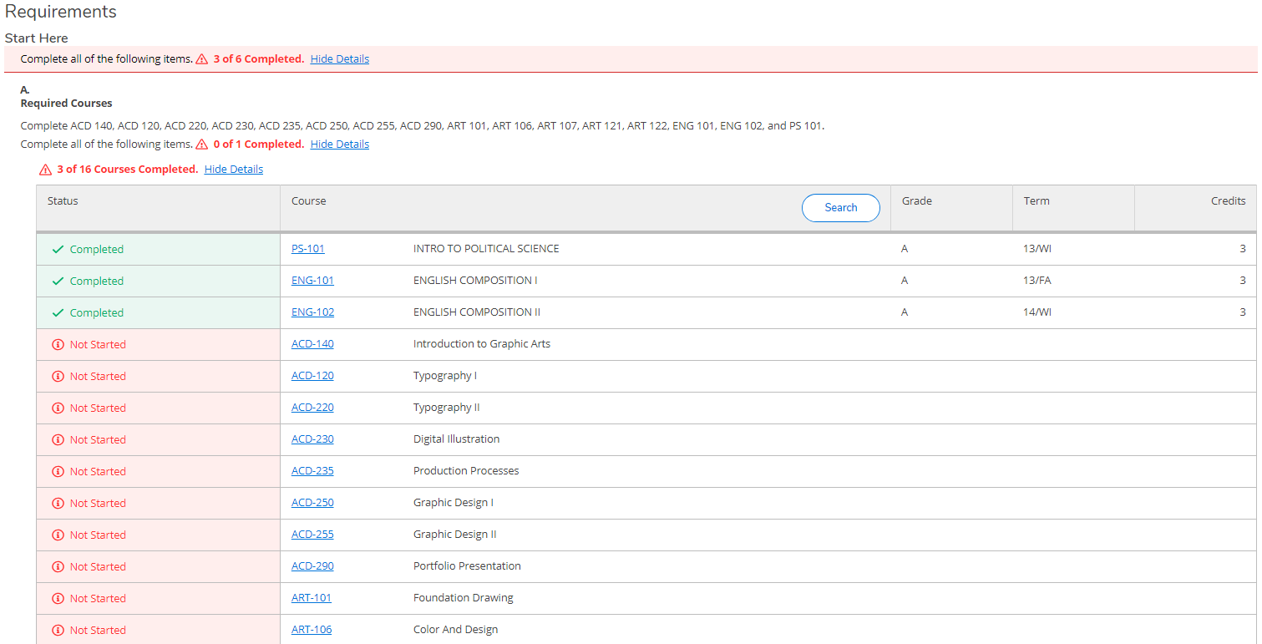

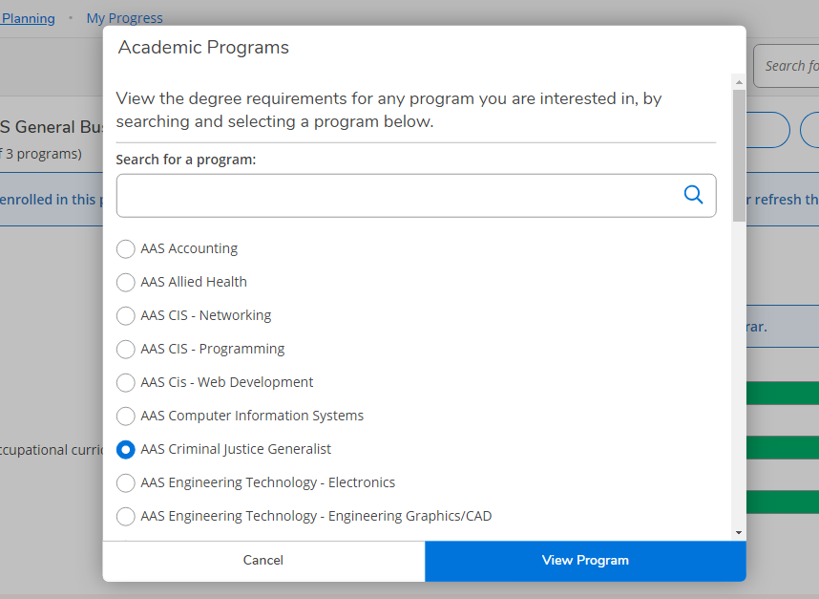
To review progress in other degree programs

**These instructions do not cover everything Portal and Student Planning can do. It is strongly suggested that you explore Portal and Student Planning to find out the many ways it can assist you and help navigate processes at SC4.

FAQ’s
How do I waitlist for a course? How do I register if I receive a seat?
- When a section is full, you have the option to “waitlist” rather than “register”. If an opening becomes available, the college will notify you via your SC4 email address (see above for further clarification on your SC4 email address).
- If you receive permission, you will have only 48 hours to register for the course (see registration instructions above).
Why am I unable to register for classes?
- Check the semester’s registration dates. You cannot register for classes before registration opens*.
- If you have any restrictions on your record, you may be prevented from registering. When you first log into Student Planning, you will see any restrictions under “notifications” in the top right corner. You need to resolve your restrictions before you may register for classes.
- If you are still having trouble, visit the One-stop, first floor of the SC4 Welcome Center, or call (810) 989-5500 for assistance.
How do I drop a registered course?
- You can drop a registered course for full tuition refund (minus the non-refundable student fee) throughout the registration/drop/add period*. Simply click the “drop” button under the desired course(s) and follow any additional prompts.
How do I drop a class after a semester’s registration/drop/add period is over?
- Once the semester’s registration/drop/add period* has passed, it will no longer be considered a dropped course, but a withdrawn course.
  - Withdrawn courses appear on your transcript as a “W” grade, and you are financially responsible for the course.
  - “W” grades do not affect your grade point average, but could have long term financial impacts. Please be sure to check with the SC4 Financial Aid office, (810) 989-5530, and/or with your SC4/program advisor.
- You can withdraw from a registered course up through the final withdrawal date of the semester*. Simply click the “drop” button under the desired course(s) and follow any additional prompts.

*To view the SC4 academic calendar please visit www.sc4.edu/academic-calendar.

